Instructions for EXP1
Implementation of Basic operations on linked list-Creation, Insertion, Deletion, Traversal, Searching an element.
Define
- Structure for linked list
- Start pointer initialized to NULL
Create functions for
- Creation of Linked List
  - Prompt the user for the number of nodes (say n) to be created in the linked list.
  - Loop needed to call that create function for n times.
- Insertion at Beginning
  - Prompt the user for Data to be inserted
- Insertion after given position
  - Prompt the user for the position after which the element is to be inserted
  - Prompt the user for Data to be inserted
- Deletion
  - Prompt the user for the element to be deleted
  - Compare the data part with the key to be deleted
- Displaying the Linked List/Traversal
- Searching an element in the linked list
  - Prompt the user for Data to be searched

Concept-
- Generating a Menu driven program using Switch case break construct for calling these functions.
- The Switch case must be placed inside a loop.
- Include the Header files needed for dynamic memory allocation and exit() function if used.

Expected Outputs:
Creation
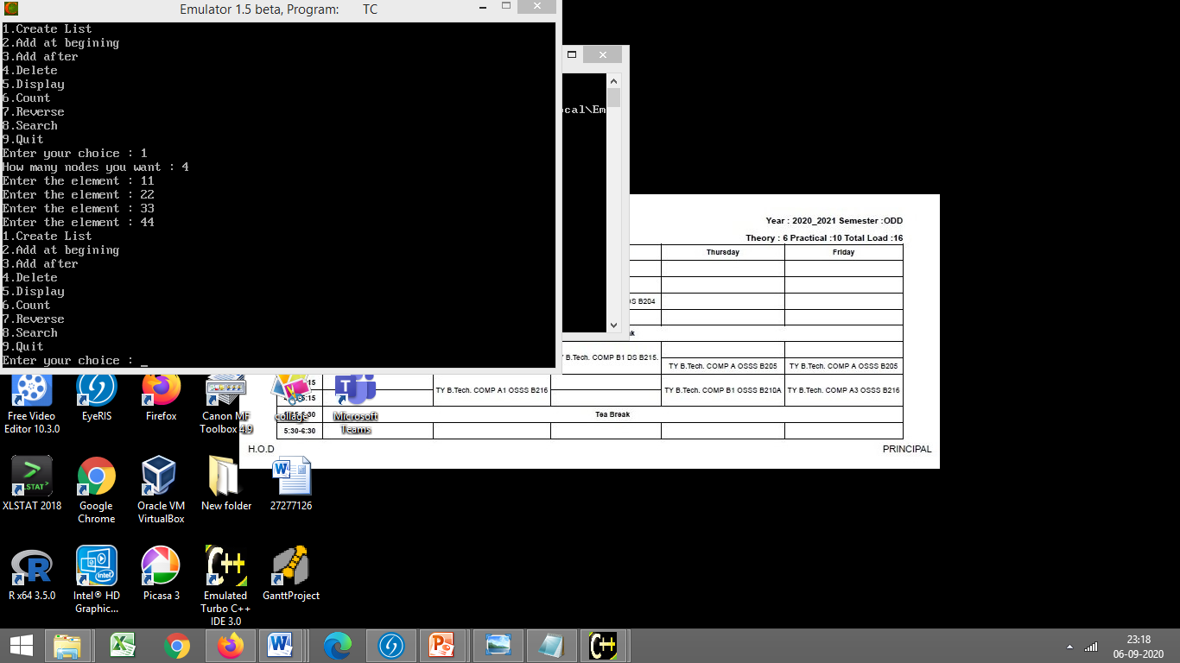
Add at beg
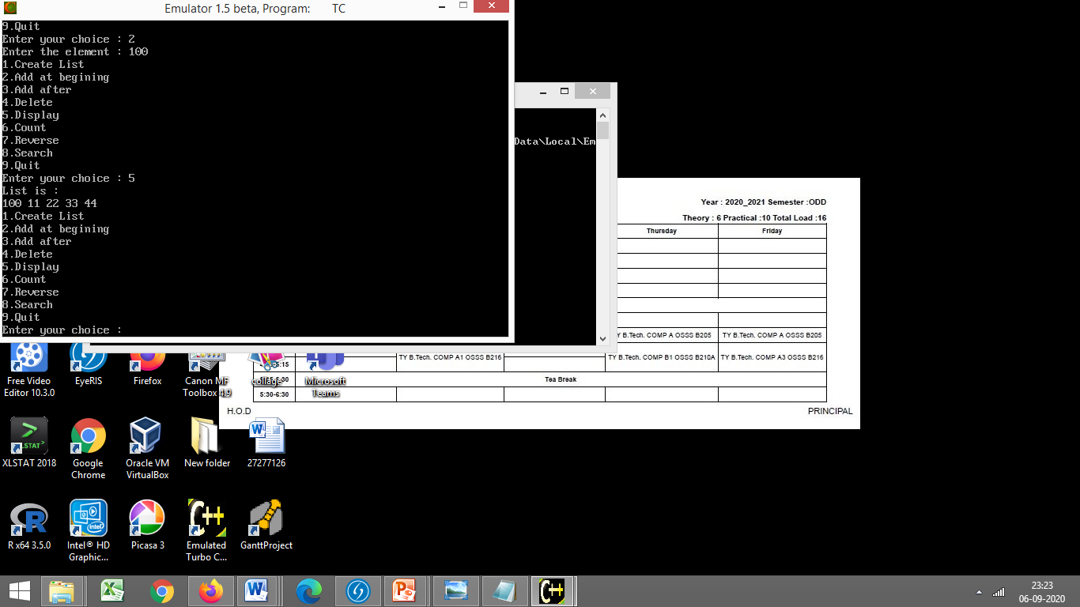

Add after position
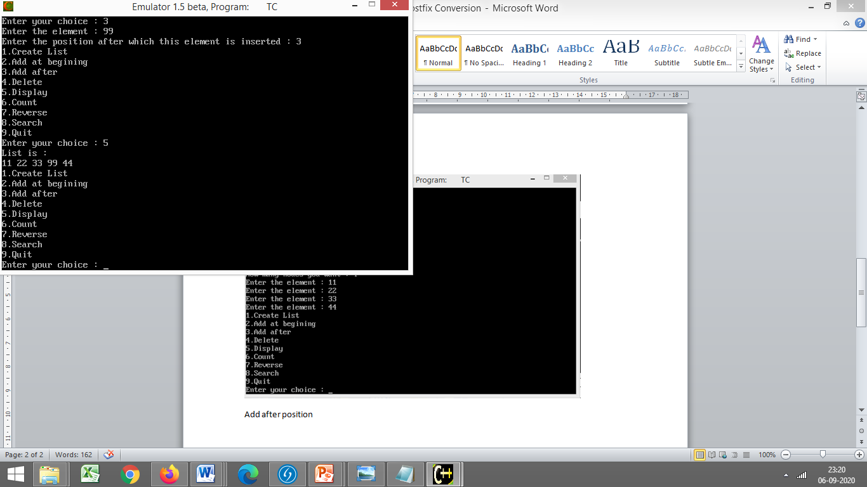
Deletion-
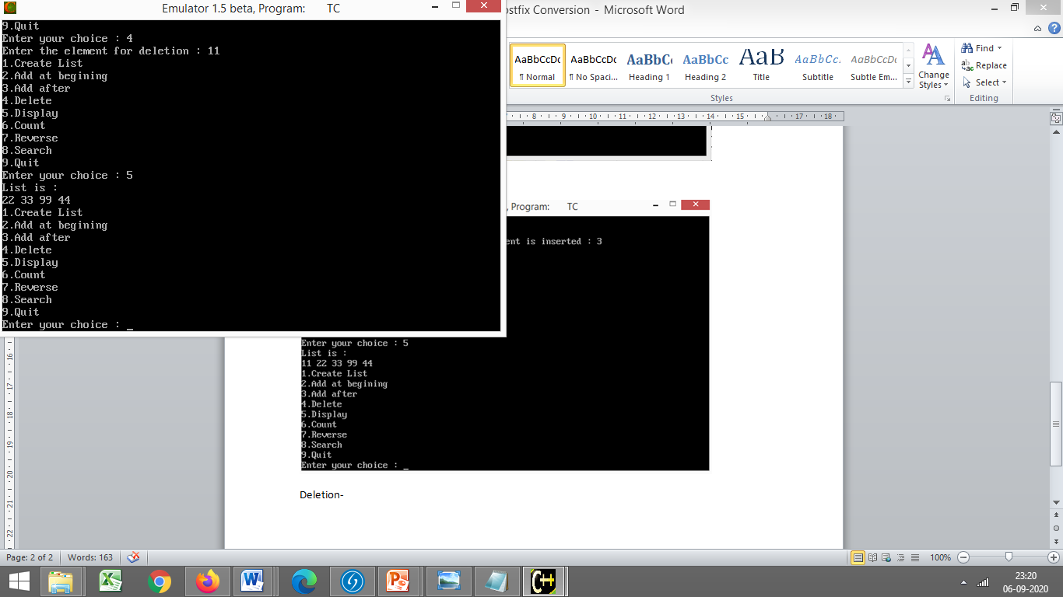

**Screenshot for each Operation performed on Linked List is required

